**21CY681 - INTERNET PROTOCOL LAB - III**

Name: Akhil K J

Register Number: CB.EN.P2CYS22009

Date: 20th October 2022

Assignment Topic: To use wireshark and analyse various HTTP packets and protocols

**By looking at the information in the HTTP GET and response messages, answer the following questions.**

1. Is your browser running HTTP version 1.0 or 1.1? What version of HTTP is the server running?

Browser version: 1.1

Server version: 1.1



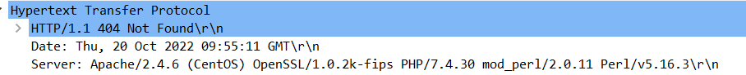

1. What languages (if any) do your browser indicate that it can accept to the server?

En-US



1. What is the IP address of your computer? Of the server?

IP Address of your computer: 192.168.170.120

IP Address of server:



1. What is the status code returned from the server to your browser?

Status code: 404 Not Found

1. When was the HTML file that you are retrieving last modified at the server?



1. How many bytes of content are being returned to your browser?



1. By inspecting the raw data in the packet content window, do you see any headers within the data that are not displayed in the packet-listing window? If so, name one.

No

1. Inspect the contents of the first HTTP GET request from your browser to the server. Do you see an “IF-MODIFIED-SINCE” line in the HTTP GET?

No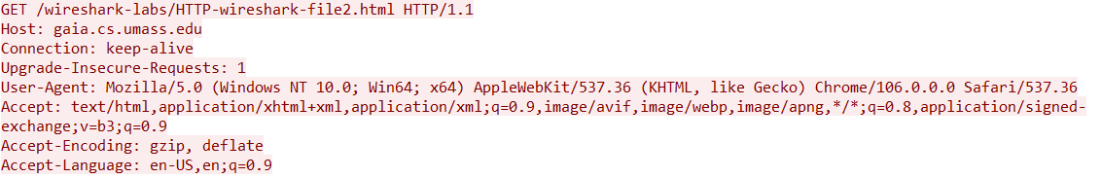

1. Inspect the contents of the server response. Did the server explicitly return the contents of the file? How can you tell?

YES

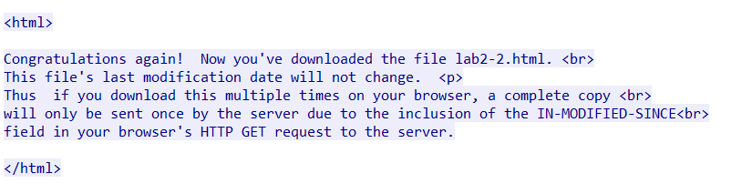

1. Now inspect the contents of the second HTTP GET request from your browser to the server. Do you see an “IF-MODIFIED-SINCE:” line in the HTTP GET?

Yes

What information follows the “IF-MODIFIED-SINCE:” header?

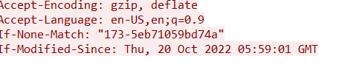

1. What is the HTTP status code and phrase returned from the server in response to this second HTTP GET? 

Did the server explicitly return the file’s contents? Explain.

NO.

1. How many HTTP GET request messages did your browser send?

2 GET REQUEST



Which packet number in the trace contains the GET message for the Bill or Rights?

1st Packet

1. Which packet number in the trace contains the status code and phrase associated with the response to the HTTP GET request?

1st Packet



1. What is the status code and phrase in the response?

Status Code: 200

Phrase: Ok

1. How many data-containing TCP segments were needed to carry the single HTTP response and the text of the Bill of Rights?

3 TCP files



1. What is the server’s response (status code and phrase) in response to the initial HTTP GET message from your browser?

Status code: 401

Phrase: Unauthorized



1. When your browser sends the HTTP GET message for the second time, what new field is included in the HTTP GET message?

Authorization is the new header included in HTTP GET message.

